Chapter 2. Understanding the Input/Output (I/O) Section

09/03/2023
Felix Feliu
Basic Programmable Logic Controllers, ECONMT-142 fall
Instructor: Mr. R.E. Iadevaia

1. Describe briefly the purpose of the I/O section.

Answer

The primary purpose of this I/O Section is ‘to convert any input/output signals into
signals that will be compatible with the processor. I/O modules act as the data
interface between the field and the CPU and get the desired output. A PLC knows the
actual status of field devices and controls them with relevant I/O cards.

2. State two reasons for employing optical isolation.

Answer

a) This eliminates any possibility of the input line voltage, i.e., 120 or 240 V AC, from
coming in contact with the processor and damaging the low-voltage DC section of the
processor.
b) also protects the processor from electrical noise, voltage transients, or spikes.

3. Draw an AC input module with four input devices, show all necessary electrical
connections, and identify potentials L1 and L2.

Answer

AC input Module with four inputs

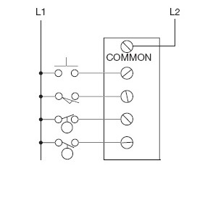

4. Draw an AC output module with four output devices to show all necessary
Electrical connections and identify potentials L1 and L2.

Answer

AC output Module with four outputs

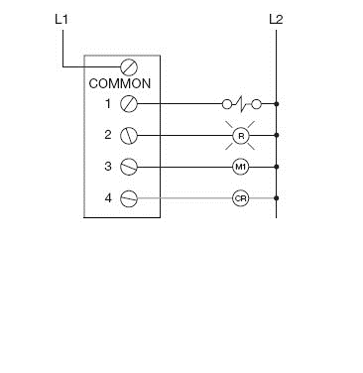
5. Triacs are susceptible to “dielectric-type” breakdown if the maximum
peak the voltage level is exceeded.

Answer
T X F

6. Briefly describe why a hard-wired emergency-stop circuit is
recommended for PLC installations.

Answer

Programmable Logic Controllers are considered Solid state devices. These
solid-state devices usually fail to shorten. This is an added hazard concerned
with the safety of the equipment. So, to avoid this, a hard-wired emergency
STOP circuit will be incorporated with the PLC system.

7. Briefly describe the function of an interposing relay.

Answer

When it is necessary to control loads larger than the rating of an individual output
circuit, a standard control relay, which has a small inrush and sealed current value, is
connected to the output module.

8. I/O modules are keyed to prevent unauthorized personnel from removing them
From the I/O rack.

Answer
T F

9. Which of the following are not normally sources of electrical noise?

a.) solenoid d.) motor starter
b.) relay e.) motor
c.) indicator lamp X f. ) overload heaters X

10. To ensure maximum benefit of shielding, the shield of a shielded cable must
be terminated and grounded at both ends.

Answer
T F X

11. E-Stop refers to:

Answer

a.) extra stop d.) elevator stop
b.) emergency stop X e.) energy stop
c.) every stop

12. Electromagnetic interference (EMI) can be reduced with the proper grounding
Of equipment.

Answer
T X F

13. Solid-state output devices tend to:

Answer

a.) never fail c.) fail in the shorted or ON conditions
b.) fail in the open or OFF condition d.) not be affected by overload

14. List three environmental considerations when installing PLC
equipment.

Answer

1. Temperature

2. Dust

3. Troubleshooting accessibility

15. What type of tool or object should be used to change the position
of DIP switches?

Answer

Use the tip of a ballpoint pen or other nonconducting pointed
object to change switch positions.

